SIMATS ENGINEERING
ASSESSMENT TOOL 3

COURSE NAME: Artificial Intelligence COURSE CODE: CSA17

COURSE OUTCOME COVERED

CO2: Experiment search and game-solving techniques such as Greedy Search, A*, CSP, Minimax, and Alpha-Beta pruning with heuristic functions for solving complex AI problems efficiently. (BL3)

Assessment Tool Weightage: 40%

Duration: 1 Hour
QUESTIONS: 3 Total Marks:30

Annexure A

Dry Run Evaluation

Code of Conduct:

I ____________________ (Name / Reg No) certify that this submission is my original work and that I have adhered to the guidelines specified for this assessment.
I understand that any violation of academic integrity rules will result in disciplinary action.

Signature of the student:

Annexure A

Dry Run Evaluation
1. Question 1 – Breadth-First Search (BFS)
Consider the following graph: A
/ \
B C
/ \ / \
D E F G
Task: Starting from node A, perform a Breadth-First Search (BFS). Complete the following table.
Iteration | Queue | Visited Node
1
2
3
4
5
6
7
Questions:
- Write the BFS traversal order.
- Show the queue contents after each iteration.

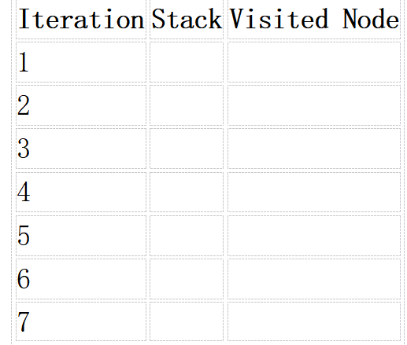
2. Depth-First Search (DFS) Using the same graph,
A
/ \
B C
/ \ / \
D E F G
Perform Depth-First Search (DFS) starting from A.
Complete the table.
- Initial State :
1 3 6
5 0 2
4 7 8

Goal State :
1 2 3
4 5 6
7 8 0

Task
Trace Breadth-First Search (BFS) until the goal state is reached.
Fill in the table.
Iteration | Current State | Queue Before Expansion | Queue After Expansion
1
2
3
4
5

Questions
- Which node is expanded in each iteration?
- How many states are generated in total?
- Write the complete solution path from the initial state to the goal state.
- Why does BFS always find the shortest solution in an unweighted 8-puzzle problem?

RUBRICS FOR CALCULATION

Criteria | Weightage (%) | Level 4 – Exemplary (4) | Level 3 – Proficient (3) | Level 2 – Developing (2) | Level 1 – Beginning (1)
Understanding of Search Problem | 20 | Clearly understands the search problem, initial state, goal state, and search strategy. | Understands the problem with minor misunderstandings. | Demonstrates partial understanding of the search problem. | Shows little or no understanding of the search problem.
State Expansion and Dry Run Execution | 30 | Correctly traces every iteration, expands nodes accurately, and maintains the Queue/Stack/Priority Queue without errors. | Performs most iterations correctly with minor mistakes in state expansion or data structure updates. | Performs only some iterations correctly; several errors in tracing or node expansion. | Unable to correctly perform the dry run or expand states.
Application of Search Algorithm | 20 | Applies the selected algorithm (BFS/DFS/UCS) correctly, following all algorithmic rules. | Applies the algorithm correctly with a few procedural errors. | Applies only basic algorithm steps with noticeable mistakes. | Fails to apply the correct search algorithm.
Accuracy of Solution Path | 20 | Identifies the correct traversal order/solution path and goal state with proper justification. | Solution path is mostly correct with minor errors. | Partially correct solution path; goal may not be reached correctly. | Incorrect or incomplete solution path.
Presentation and Logical Reasoning | 10 | Queue/Stack/Priority Queue updates, state diagrams, and explanations are neat, organized, and logically presented. | Presentation is clear with minor organizational issues. | Limited explanation and organization; reasoning is partially clear. | Poor presentation with unclear or missing reasoning.

1. Breadth-First Search (BFS)

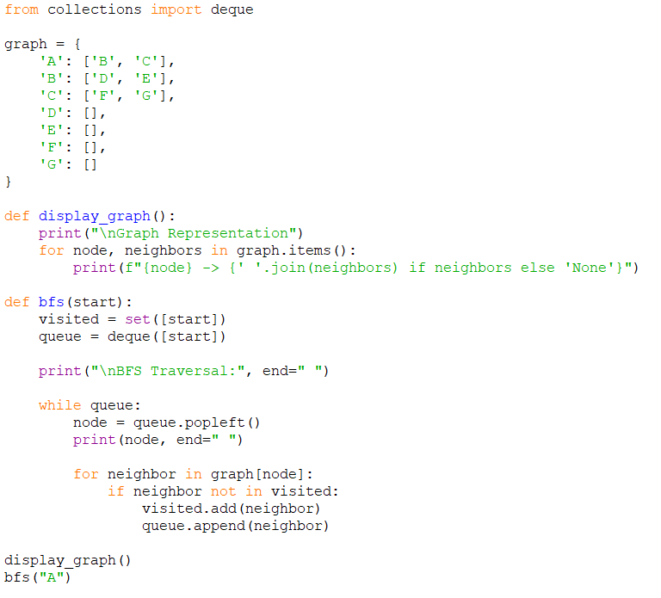

Output:

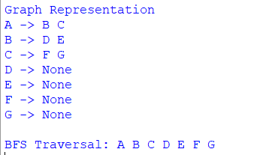

2. Depth First Search (DFS):

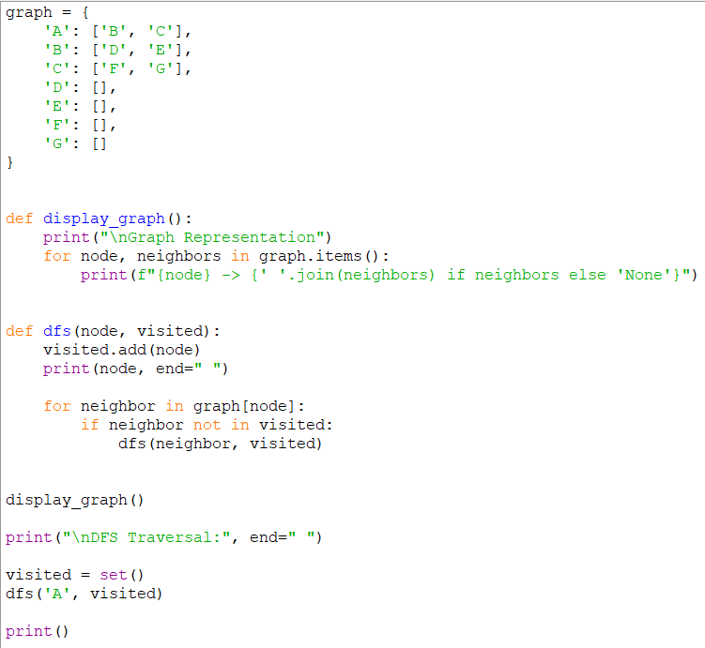

Output:

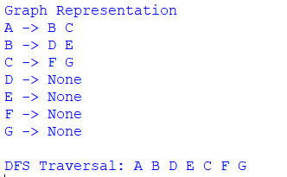

3.Eight Puzzle Solver:

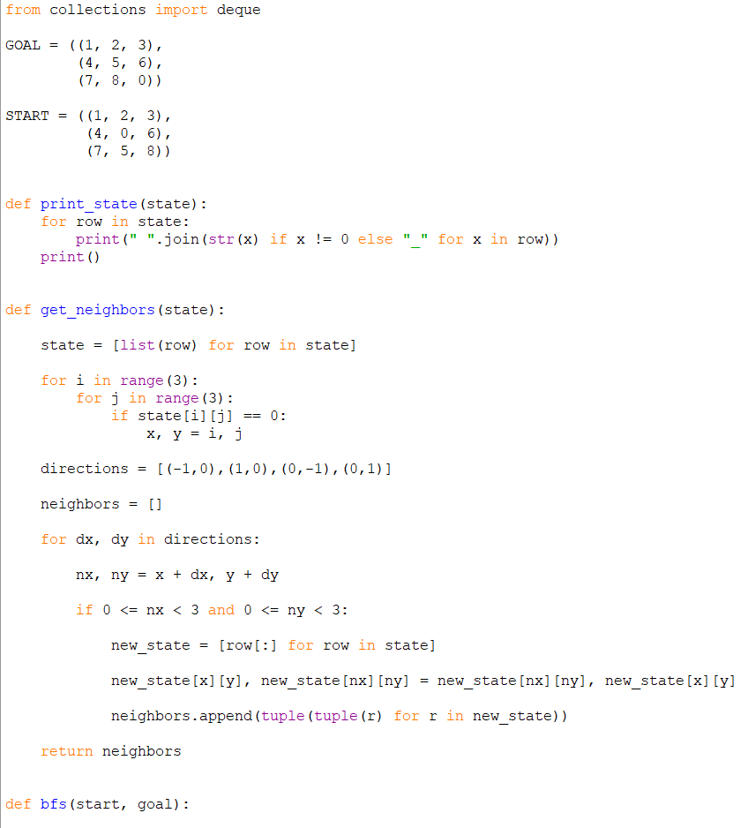
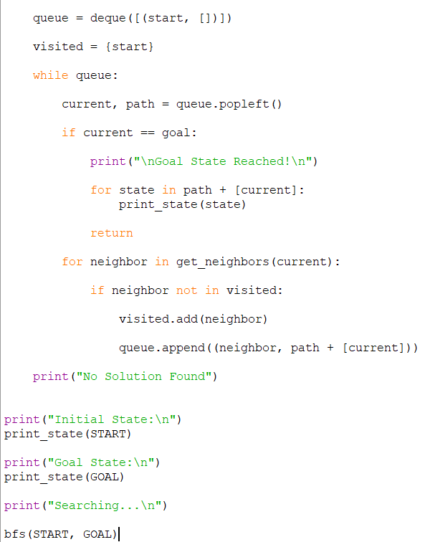

Output:

